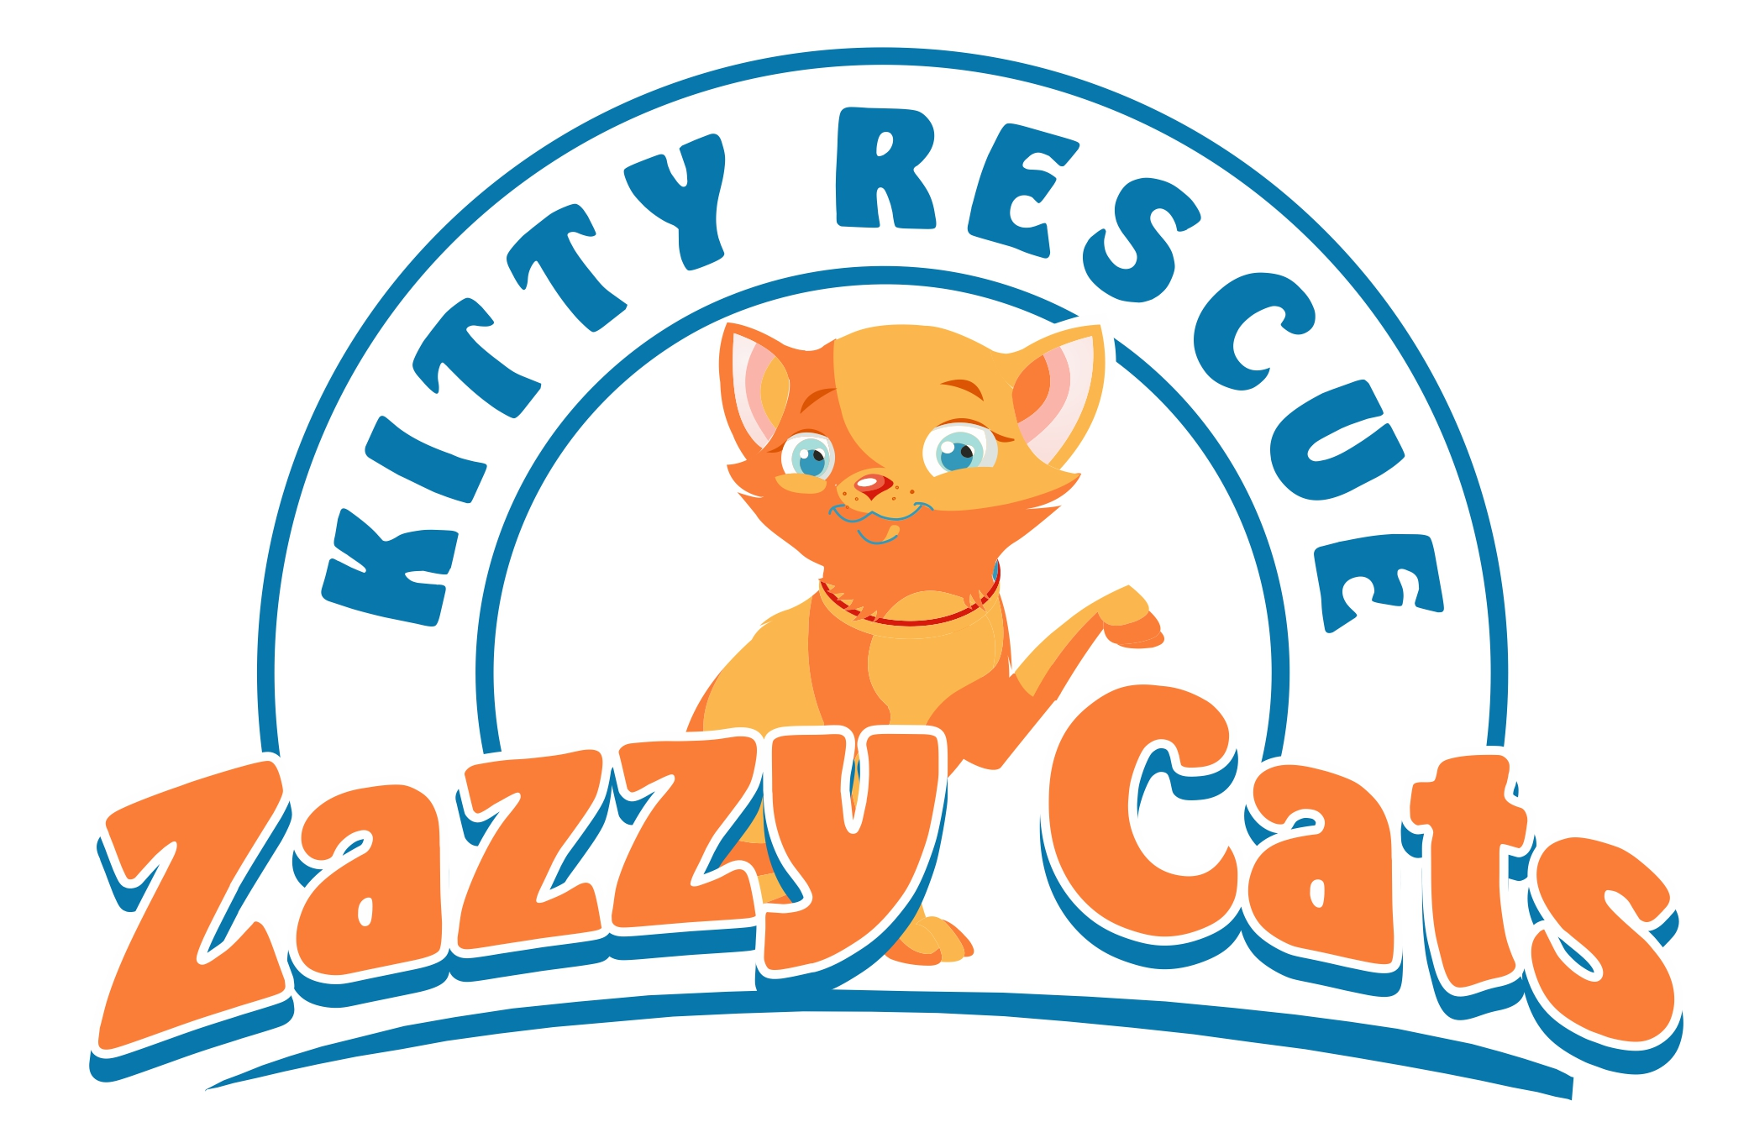
VOLUNTEER APPLICATION
Contact Information
Name (First/Last)
Street Address
City State Zip Code
Preferred Phone
2nd Phone
Email
Person to Notify in Case of Emergency
Name
Relationship
Phone Number
Personal Information
How old are you, if under 18 please provide birthdate
Do you have your own transportation
Do you own or have you previously owned a cat
Have you ever been convicted of a crime, felony or non-traffic misdemeanor? If yes, please provide details
Date of last tetanus shot |  | (We recommend all volunteers to be current)
Best time to contact you
When are you available  (select all that apply) |  | [ ]Mon [ ]Tues [ ]Wed [ ]Thurs [ ]Fri  [ ]Sat [ ]Sun [ ]AM’s [ ]PM’s
Desired Position (select all that apply) |  | [ ]Adoption Center Cleaner [ ]Socializing Cats [ ]Laundry  [ ]Home Fostering [ ]Medical Caregiver [ ]Transporting
Volunteering Information
How did you hear about Zazzy Cats Kitty Rescue
Why are you interested in volunteering
How long do you plan to volunteer? |  | (6 month commitment is preferred)
Previous experience, skills, or hobbies you wish to share
Are you currently volunteering with another rescue or animal organization?
Are you interested in special events & fundraising projects |  | [ ]Grant Writing [ ]Marketing/Publicity [ ]Committee Member [ ]Poster/Flyer Distributor [ ]Event Setup & Teardown
Interested in volunteering for technical needs |  | [ ]Internet surfing/research [ ]Social Media [ ]Photo/Video [ ]Telecommunications [ ]Website Designer
Are your volunteer activities intended to satisfy any court-ordered or otherwise community service requirements? If yes, please provide details
Other Special Skills
VOLUNTEER APPLICATION

Volunteer Agreement

I certify that I have never been charged or convicted of animal abuse or neglect.

I will abide by the mission, rules, regulations, policies & programs of Zazzy Cats Kitty Rescue while I am a volunteer.

I understand Zazzy Cats Kitty Rescue is an all-volunteer, non-profit organization and that the cats are dependent on volunteers for affection, patience, kindness, food and compassionate care.

I agree to complete the tasks assigned each time I volunteer.

In the event I am unable to volunteer during an assigned shift, I agree to contact the volunteer coordinator no later than 24 hours prior to my scheduled shift.

If I do other types of volunteer work for Zazzy Cats Kitty Rescue, I agree to immediately notify the appropriate person in charge if I am unable to complete the work.

If I believe I have contacted a medical condition that may be communicable to the cats (such as toxoplasmosis or ringworm), I agree to notify the foster coordinator immediately.

I understand that, as a volunteer, I may gain access to information about the organization that is confidential. I agree to respect and maintain the confidentiality of all donors, volunteers and other individuals working with Zazzy Cats Kitty Rescue both on and off site, during and outside of volunteer hours.

If I discontinue volunteering for any reason, or upon Zazzy Cats Kitty Rescue’s request, I will promptly return all Zazzy Cats Kitty Rescue’s supplies, equipment, records, money and any other items in good condition.

I have completed this application and agreement accurately and truthfully. If any false information is provided, it may nullify my ability to volunteer with Zazzy Cats Kitty Rescue.

Volunteer Signature Date

I acknowledge that I will be performing volunteer services for Zazzy Cats Kitty Rescue Inc. (ZCKR), a 501c3/ California non-profit organization. I further understand that there are certain risks that may be associated with such volunteer activities. In consideration of being permitted to perform such volunteer services for ZCKR, I voluntarily and knowingly sign this waiver with the express understanding of waiving all rights or causes of action involving, without limitation, bodily injury to myself, or property damage while I am engaged, directly or indirectly, in such volunteer services, whether caused by the negligence of ZCKR or its officers, directors, agents, Rescue Partners( ie..PetSmart, Stray Cat Alliance, LBACS) and/or volunteers.

Further, I shall indemnify, defend, and hold harmless ZCKR and its officers, directors, agents, and volunteers from and against any and all liability, damage, loss, cost, and expense incurred as a result of any claim, demand, or cause of action brought against ZCKR, its officers, agents, or volunteers, jointly or individually, for bodily injury or property damage suffered as a result of my negligent, reckless, or willful action in the performance of the volunteer services or as a result of the failure to perform the volunteer services.

Volunteer Signature Date

